Name............................................................ Date..............................................................................
Please indicate with X any items that appear to you as a hazard.

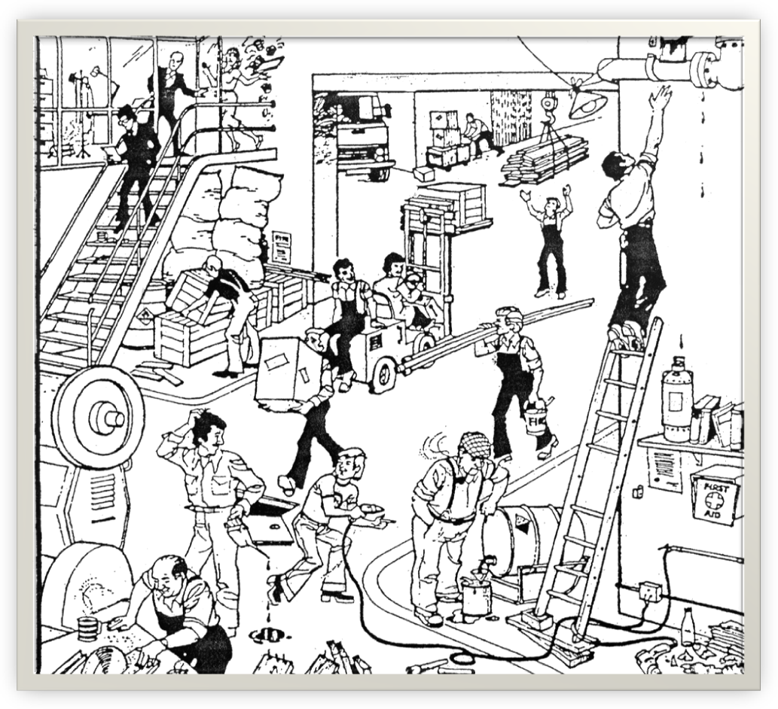

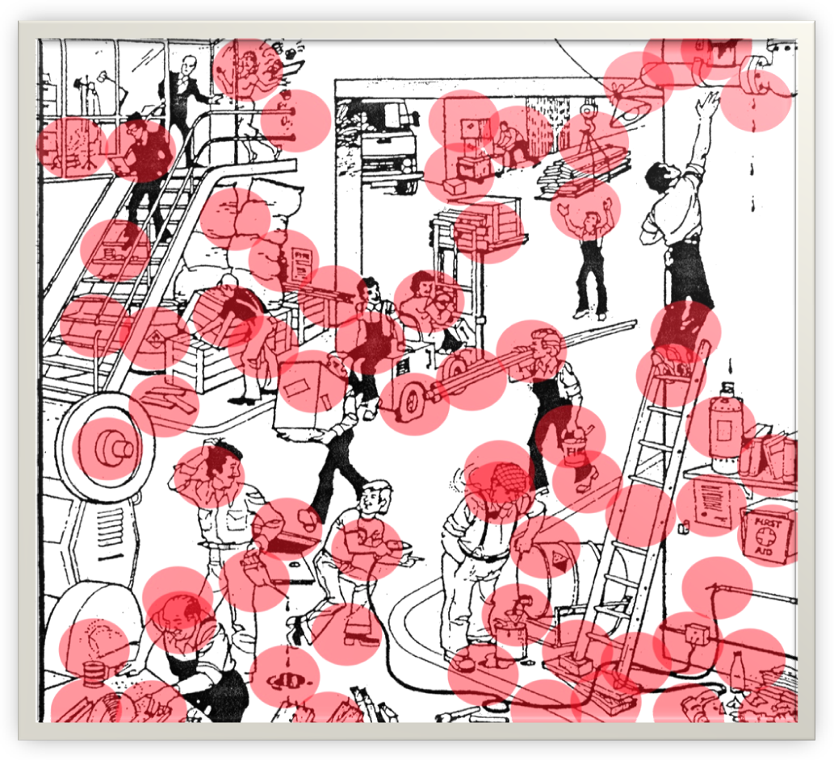
Others Hazards could be.......
- Noise
- Vibration
- Fumes
- Dust
- Work place transport
- Fire

